**Phase 8: Data Management & Deployment**

**Objective:**

The goal of this phase was to populate the org with realistic sample data to test all functionality and to package the completed configuration and code for deployment.

**Completed Actions:**

* **Data Import:** Sample customer data was imported into the org to simulate a real-world environment. The **Data Import Wizard** was used to import Accounts and Contacts from CSV files. This provided a set of customers to which support cases could be assigned.
* **Sample Case Creation:** Several sample Case records were manually created and linked to the imported sample data. This was a critical step to test the end-to-end functionality of the automation (Flow and Apex Trigger) and to provide realistic data for the reports and dashboard.
* 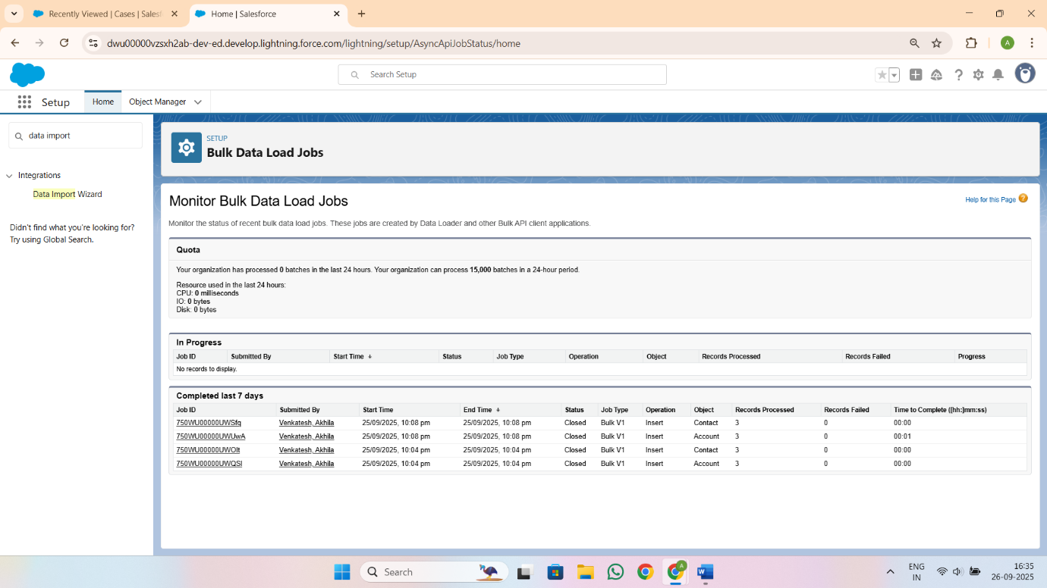**Deployment Preparation:** All the project's components—including custom objects, fields, automation rules, Apex code, and UI configurations—were conceptually prepared for deployment. In a real-world scenario, this would involve retrieving the metadata from the development org using a tool like **VS Code & SFDX** to move it to a testing or production environment.

